**2018 Duplin County Livestock Show**

**Eastern Showmanship Circuits**

Duplin Livestock Facility

275 Fairgrounds Dr., Kenansville, NC

Duplin Cooperative Extension: 910-296-2143 (Day of 910-271-0897)

**Pig Show: September 13th**

Weigh-in: 4:00-5:00, Show: 6:00pm



**Goat Show: September 14th**

Weigh-in: 4:00-5:00, Show: 6:00pm

**Lamb Show: September 15th**

Weigh-in: 8:00-9:00, Show: 10:00am

**Heifer Show: September 15th**

Check-in: 11:00-12:00, Show: 1:00, or conclusion of lamb show

**Rules**

1. Showmanship age divisions based on exhibitor’s age as of January 1, 2018.
2. Animals used in showmanship competition must be entered in the Duplin Livestock Show in the name of the showmanship exhibitor.
3. Shows are open to ages 5-18.
4. **All animals must meet NC health requirements. No sick animals will be allowed to show!**
5. Decisions of judge are final.
6. Unsportsmanlike conduct will not be tolerated.
7. Disputes will be handled by the show committee and circuit boards.
8. Each exhibitor can show 2 animals from each species.
9. Monetary prizes for champion animals will be mailed after the show.
10. All animals must have a form of identification (tags, tattoo, etc.)

**Goats & Sheep**

1. All animals must have a scrapie tag.
2. All horn tips must be dulled and/or blunt.
3. Must have all baby teeth the day of the show.
4. No bucks allowed.
5. Market classes will be divided by weight.

**Heifers**

1. All animals must be halter broke, unruly heifers will be asked to leave show ring.
2. Heifers must be born on or after November 1, 2015.

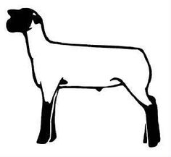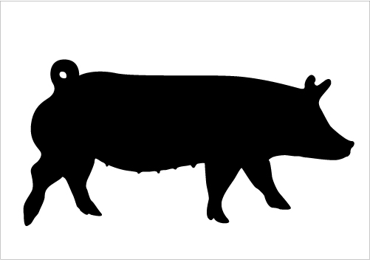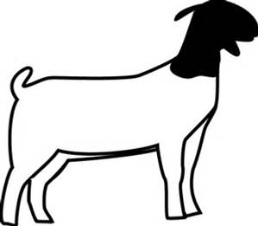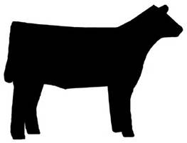

**Duplin County Livestock Show Registration Form**

Name__________________________________________Parent________________________________________

Cell Number______________________________________Age as of January 1, 2018_______________

Address_________________________________________________City_________________Zip_____________

County________________________________Email__________________________________________________

|  |  |  |
| --- | --- | --- |
| **Species**  **(Hog, Lamb, Heifer, Goat)** | **Tag or Tattoo** | **Date of Birth**  **Heifers Only** |
|  |  |  |
|  |  |  |
|  |  |  |
|  |  |  |
|  |  |  |
|  |  |  |
|  |  |  |

**$10/Exhibitor Entry Fee (Additional $10/family for late entries)**

**Mail Checks & Forms by September 8th to:**

Duplin Agri-Community Foundation

Att: Charmae Kendall

PO Box 949, Kenansville, NC 28349

I have read the attached rules and regulations and agree to comply with these regulations as set forth by the Duplin County Livestock Show Committee. The sponsors, committee, and exhibitors will not be responsible for any damages or injury that may occur in conjunction with the show.

While every attempt will be made to provide a safe environment for animals, exhibitors, and spectators, the Duplin County Livestock Show Committee, and Sponsors will not be held responsible for any accidents or injuries that may occur. Exhibitor and/or guardian agrees to hold and indemnify Duplin County Livestock Show Committee, and Sponsors harmless from any and all liability arising out of exhibitors use of grounds, including any and all injury or damage to exhibitor and/or animal or any participants and the public. Show Committee will not be held responsible for any lost personal items.



Exhibitor’s Signature_______________________________________Date____________

Parent Signature____________________________________________Date____________

